INTRODUCTION

Problem types Ansys55_plane.gid and Ansys55_3D.gid permits to define the model to analyze inside Gid and transfer the data to Ansys, where the analysis is automatically performed. The post processing stage can be made in Ansys or Gid.
The problem type Ansys55_plane.gid can be used to define geometry, materials, conditions and mesh for plane stress and plane strain problems.
Both problems have their conceptual definition on the bi dimensional elasticity theory in which loads and deformation are only defined in model plane.
For the plane strain problem, it is supposed that perpendicular displacement to plane model is zero but stress is not, on the other hand, in the plane stress problem it is supposed that perpendicular displacement to plane model is non-zero but stress is zero.
For plane strain problems, default thickness (thickness=1) is used for analysis; Loads have to be expressed using unitary thickness to obtain coherent results.
For plane stress problems, real model thickness must be introduced to perform analysis.

Problem type Ansys55_3D.gid can be used to define geometry, materials, conditions and mesh for 3D problems.
The type of analysis that can be done for all problems is linear elastic.
This manual is organized in the following way:
Using GID as pre-processor:
Define geometry
Assign restrictions and loads
Assign materials
Generate an adequate finite element mesh
Generate an Ansys run analysis type file.
Once the model is finished read the file generated by Gid in Ansys and run the analysis.
Once the analysis finishes, generate result files so post process can be done in Gid.
To describe the previous steps, two easy examples are done.
GENERALITIES

Units: Ansys does not work with an explicit set of units, user must choose the set of units for all data input so coherent results will be obtained after analysis is done.
Geometry: Generation of model geometry can be done using GID drawing capabilities, or importing a CAD file to define in it the entities required to make a well posed problem.
Loads: Ansys takes positive loads acting toward the model. It’s better to define all system loads over the different entities: points, lines, and surface instead defining directly over the mesh. This procedure will not require redefinition of load conditions due to possible mesh refinements.
Plane problem:
Loads at points:
Forces can be applied at nodes in the available degrees of freedom; moments acting perpendicularly to model plane can also be applied.
Loads over lines:
Uniform distributed loads (pressure) over lines can be applied to model.
Space problem:
Loads at points:
Forces can be applied at nodes in the available degrees of freedom Fx, Fy and Fz; moments around global coordinate system X, Y and Z can also be applied.
Loads over surface:
Uniform distributed loads (pressure) can be applied to model.

Constraints: constraints can be applied to the different entities of the model points, lines, and surfaces.
All plane problem elements have two degrees of freedom at each node UX, UY
In space (3D) problems elements may vary their DOF, for linear elements 6 DOF are available per node UX, UY, UZ, ROTX, ROTY, ROTZ.
For quadratic elements 3 DOF are available per node UX, UY, UZ.
Plane problem:
Constraints at points:
Each available degree of freedom can be constrained in points.
Constraints over lines:
Each available degree of freedom of all nodes lying over the line can be constrained.
Space problem:
Constraints at points:
Each available degree of freedom can be constrained in points.
Constraints over lines:
Each available degree of freedom of all nodes laying over the line can be constrained.
Constraints over surface:
Each available degree of freedom of all nodes laying over the surface can be constrained.
Materials: materials can be assigned to model on the different entities: surface and volume.
Plane problem:
Materials can be assigned on surfaces.
Space problem:
Materials can be assigned on volume.
Mesh: Ansys allows mesh refinements in any fashion user needs to specify, so all Gid’s capabilities for mesh refinements can be used; elements that are allowed for meshing generation are:
Plane problem:
Triangles with quadratic approximation (6-node) known as PLANE2
Quadrilateral with lineal approximation (4-node) known as PLANE42
Quadrilateral with quadratic approximation (8-node) known as PLANE 82
Space problem:
Tetrahedral with linear approximation (4-node) known as SOLID72
Tetrahedral with quadratic approximation (10-node) known as SOLID92
Hexahedral (structured mesh) with linear approximation (8-node) known as SOLID73
Hexahedral (structured mesh) with quadratic approximation (20-node) known as SOLID95
PROBLEM ANSYS55_PLANE.GID

DESCRIPTION OF THE MODEL:

In this example a 0.25m square plate side, with 0.01m of thickness and a 0.025m diameter center circular hole perforation will be analyzed.
Static 1000 MPa/m. load acting on external ED side will be applied.
Due to symmetric conditions only one forth of the model will be analyzed; the AB and CD borders will be constrained with symmetrically conditions.
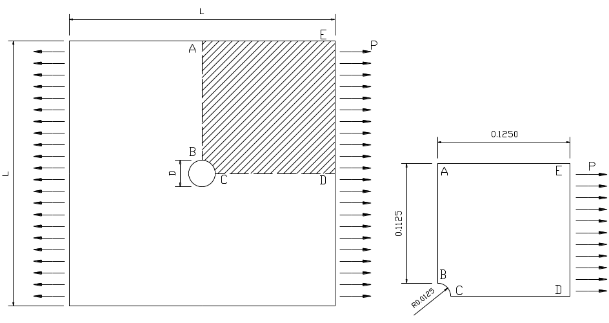

GENERATING THE MODEL WITH GID:

SELECTING THE PROBLEM TYPE:

First selected the problem type Ansys_plane.gid in

DATA / PROBLEM TYPE / ANSYS55_PLANE

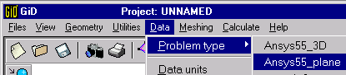The description of problem data is made with:

DATA / PROBLEM DATA
This will open the window with the following options:
Type of Analysis:
For the plane problem it is only possible to conduct a static linear analysis

Type of Problem:
Select the type of problem to resolve plane stress or plane strain
Title:
Ansys will use this name to save all data file generated during analysis (no blank spaces are allowed).
Units:
User might select (for informative purposes only) the set of units used during problem generation.
Solver:
Ansys automatically choses an iterative solver method
Precision:
Selects the accuracy level for convergence of solution of the iterative method chosen by program, the higher the number the most accurate level obtained.
Post processor:
Selects where the post process of analysis results will take place.
Thickness:
Assign the thickness to the model. If a plane stress problem is going to be done thickness must be 1. For this example thickness is 0.01m.

GENERATING THE GEOMETRY:

Node definition:
Model generation starts with node generation.

GEOMETRY / CREATE / POINT
The model will be generated on the X Y plane; it will be necessary to introduce the coordinates X Y of the points in the command line separating point coordinates with periods (,) and points with a blank space, for this problems values should look like: .0125,0 .125,0 .125,.125 0,.125 0,.0125.
It is possible to omit this step and start defining lines without previous point definition, but to be coherent with Ansys procedures point generation is not omitted.

Defining lines
The model contour will be generated with lines

GEOMETRY / CREATE / LINE
picking directly on the screen the points previously generated using the mouse option for it
(Right Button) CONTEXTUAL / JOIN C-a

Creating the arc:
Creation of the circumference arc portion can be done in many ways one can be by a three-point arc

GEOMETRY / CREATE / ARC
clicking on the starting point of the arc (.0125,0) then calculating both coordinates of the second point by SQRT((.125)^2+(.125^2) and finalizing with the last point (0,.0125)

Creating the surface
After the model contour is defined, the surface has to be created by the previously defined contour lines.

GEOMETRY / CREATE / NURBS SURFACE / BY CONTOUR
Select all lines that define the model contour.

ASSIGNING CONTOUR CONDITIONS:

Restriction of movement:
Applying the contour conditions

DATA / CONDITIONS
opens the following options
Side AB will have constrained movement along X direction
TYPE: OVER LINES
CONDITION : LINE-CONSTRAIN
X CONSTRAIN: 1
Y CONSTRAIN: 0
Side CD will have constrained movement along Y direction
TYPE: OVER LINES
CONDITION: LINE-CONSTRAIN
X CONSTRAIN: 0
Y CONSTRAIN: 1

Applying loads
Applying the contour conditions

DATA / CONDITIONS
opens the following options
Side ED will have the uniform distributed load
TYPE: OVER LINES
CONDITION: LINE-LOAD
NORMAL PRESSURE: -1000 MPa/m
ASSIGNING MATERIAL:

Material assignment:
Material will be assigned to in the

DATA / MATERIALS
For assigning material to the surface

ASSIGN / SURFACE

GENERATING THE MESH:

Mesh control:
Ansys allows refinements of meshes; high stress concentration should occur near the circular perforation, so it will be necessary to concentrate elements near this zone to correctly capture the stress concentration.
To do this it will be necessary to divide arc in an equal number of spaces

MESHING / STRUCTURED / LINES
entering the number of division desired and then selecting the arc.

Mesh generation:
In this example triangular elements are used; to generate mesh, first one needs to select quadratic elements

GENERATION / QUADRATIC ELEMENTS / QUADRATICS
Then generate the mesh over the model

GENERATION / GENERATE
An appropriated element size should be chosen in order to obtain the number of elements desired; Remember that previously you have chosen to divide arc in a equal number of spaces so this new element size will not affect the arc zone.

CREATE file_name.ans FILE:

When model is ready for running analysis it has to be created the .ans file, which will be read by Ansys
CALCULATE / CALCULATE

This concludes the pre-process in GID for the plane problem.
PROBLEM ANSYS55_3D.GID

SELECTING THE PROBLEM TYPE:

First selected the problem type Ansys_plane.gid in

DATA / PROBLEM TYPE / ANSYS55_3D
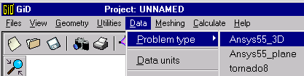
The description of problem data is made with:

DATA / PROBLEM DATA
This will open the window with the following options:
Type of Analysis:
For this problem it is only possible to conduct a static linear analysis
Title:
Ansys will use this name to save all data file generated during analysis.
Units:
User might select (for informative purposes only) the set of units used during problem generation.
Solver:
Ansys automatically choses an iterative solver method (no user selection available)
Precision:
Selects the accuracy level for convergence of solution of the iterative method chosen by program, the higher the number the most accurate level obtained.
Post processor:
Selects where the post process of analysis results will take place.

DESCRIPTION OF THE MODEL:

This example is the same used for the plane stress problem. A 0.25m square plate side, with thickness of T=0.01m and a 0.025m diameter center circular hole perforation.
Static 1000 Mpa/m^2. load acting on side EDIJ will be applied.
Due to symmetric conditions only one forth of the model will be analyzed.
ABGF and CDIH borders will be constrained with symmetrically conditions.

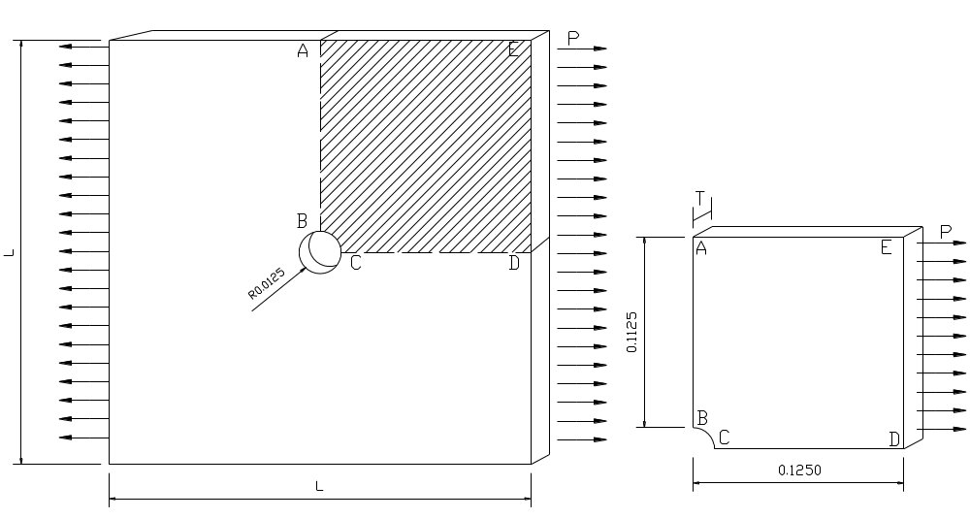

GENERATING THE MODEL WITH GID:

The geometry of this example start right after the geometry definition for the plane problem finish, it is necessary to extrude the surface previously created in order to generate the volume.

Surface Extrude:
After the model surface is defined, it has to be extruded so the volume can be generated.

UTILITIES / COPY
opens the following options
ENTITIES TYPE: SURFACE
TRANSFORMATION: TRASLATION
FIRST POINT: (SELECT A POINT ON THE MODEL)
SECOND POINT: (SELECT THE SAME POINT AND CHANGE THE Z CORD TO 0.01)
DUPLICATE ENTITIES: DEFAULT
DO EXTRUDE: SURFACE
CREATE CONTACTS: DEFAULT
MULTIPLES COPYES: DEFAULT
select the surface and press finish.

Creating the volume:

GEOMETRY / CREATE / VOLUME / BY CONTOUR
Select all the surfaces created in the previous step and press ESC

ASSIGNING CONTOUR CONDITIONS:

Restriction of movement:
Applying the contour conditions

DATA / CONDITIONS
opens the following options

USING LINEAR TETRAHEDRALS.
Side ABGF will have constrained movement along X and Z, due to non exact approximation of linear 3D elements Ansys SOLID 72 and SOLID 73 elements have rotational DOF option available.

TYPE: OVER SURFACE
CONDITION : SURFACE-CONSTRAIN
X CONSTRAIN: 1
Y CONSTRAIN: 0
Z CONSTRAIN: 1
ROTX CONSTRAIN: 0
ROTY CONSTRAIN: 0
ROTZ CONSTRAIN: 0

Side CD will have constrained movement along Y and Z.
TYPE: OVER SURFACE
CONDITION: SURFACE-CONSTRAIN
X CONSTRAIN: 0
Y CONSTRAIN: 1
Z CONSTRAIN: 1
ROTX CONSTRAIN: 0
ROTY CONSTRAIN: 0
ROTZ CONSTRAIN: 0
USING QUADRATIC TETRAHEDRALS.
Side ABGF will have constrained movement along X and Z direction.
TYPE: OVER SURFACE
CONDITION : SURFACE-CONSTRAIN
X CONSTRAIN: 1
Y CONSTRAIN: 0
Z CONSTRAIN: 1

Side CD will have constrained movement along Y and Z direction.
TYPE: OVER SURFACE
CONDITION: SURFACE-CONSTRAIN
X CONSTRAIN: 0
Y CONSTRAIN: 1
Z CONSTRAIN: 1

Applying loads
Applying the contour conditions

DATA / CONDITIONS
Side EDIJ will have the uniform distributed load
TYPE: OVER SYRFACE
CONDITION: SURFACE-LOAD
NORMAL PRESSURE: -1000MPa/m.

ASSIGNING MATERIALS:

Material assignment:
Material will be assigned to in the

DATA / MATERIALS
For assigning material to the volume

ASSIGN / VOLUME

GENERATING THE MESH:

Mesh control:
Ansys allows refinements of meshes; high stress concentration should occur near the circular perforation, so it will be necessary to concentrate elements near this zone to correctly capture the stress concentration.
To do this it will be necessary to divide both arcs in an equal number of spaces

MESHING / STRUCTURED / LINES
entering the number of division desired and then selecting both arcs.

Mesh generation:
In this example tetrahedral elements are used

GENERATION / GENERATE
An appropriated element size should be chosen in order to obtain the number of elements desired; Remember that previously you have chosen to divide both arcs in a equal number of spaces so this new element size will not affect the arcs zone.

CREATE file_name.ans FILE:

When model is ready for running analysis it has to be created the .ans file, which will be read by Ansys
CALCULATE / CALCULATE

This concludes the pre-process in GID for the 3D problem.
RUNNING ANALYSIS IN ANSYS:

Opening Ansys

Operative system Microsoft
Find the executable icon, which launch Ansys program.

Operative system UNIX
Depending on user privileges over the network, a copy of the executable file XANSYS has to be done into user’s hard drive to execute program.

Opening Ansys program:
double click on XANSYS icon will open the window to start using Ansys program

XANSYS / INTERACTIVE
Working Directory: selects directory where Ansys save results.
Run: opens the following windows:
ANSYS MAIN MENU, ANSYS OUTPUT, ANSYS GRAPHICS, ANSYS INPUT, ANSYS TOOL BAR, ANSYS UTILITY MENU.

Reading model with ANSYS
To read the .ans extension file generated in GID

ANSYS UTILITY MENU / FILE / READ INPUT FILE FROM
READ FILE window opens, path to file .ans has to be introduced; after accepting selection the analysis starts.
ANSYS OUTPUT window shows the current status of the process.
If no errors where found "SOLUTION IS DONE" window should appear to confirm that process is finished.

Exporting results:

ANSYS MAIN MENU/GENERAL POSTPROC/LIST RESULT/NODAL SOLUTION
[PRNSOL] list nodal solution / DOF solution / ALL DOFS list all nodal solution for every available degree of freedom; this list has to saved in a file so it can be read in GID for post process procedures.

ANSYS MAIN MENU/GENERAL POSTPROC/LIST RESULT/ELEMENT SOLUTION
[PRNSOL] list element solution / STRAIN ELASTIC / COMPONENT EPEL lists all elastic components of strain; this list has to be saved in a file so it could be read in GID for post process procedures.

VIEWING RESULTS IN GID

Reading Ansys file
The result running analysis files generated by Ansys has to be read in GID in order to start the post process

ANSYS / READ ANSYS FILE
Next is needed to write down or browse the current path of files containing nodal solution and elastic components of strain for every available degree of freedom.
This process has to made once for each of these two files
Pass to post process.

FILE / POST PROCESS
Which takes us to the post process option of GID; graphical results can be seen by

VIEW RESULTS

This concludes our two examples

